# 1RUBEN BEST FORM

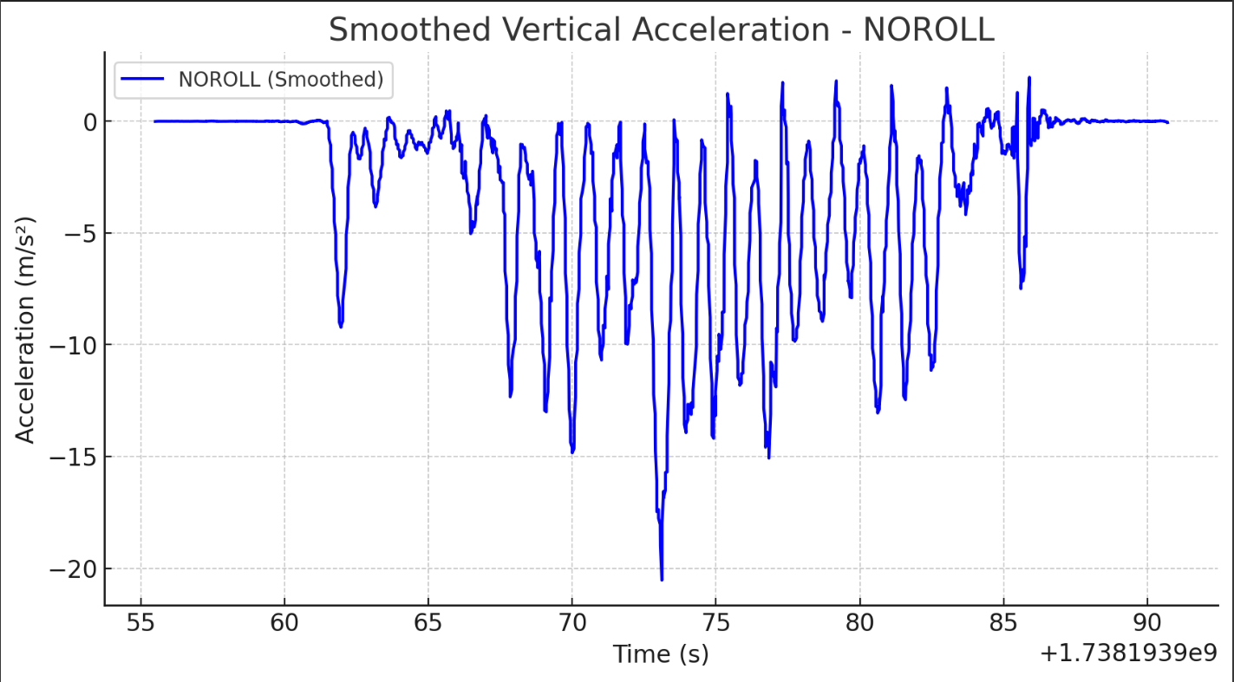

Benchmark Velocity:

.62

65

64

67

71

63

63

64

# 2RUBEN BEST FORM 2

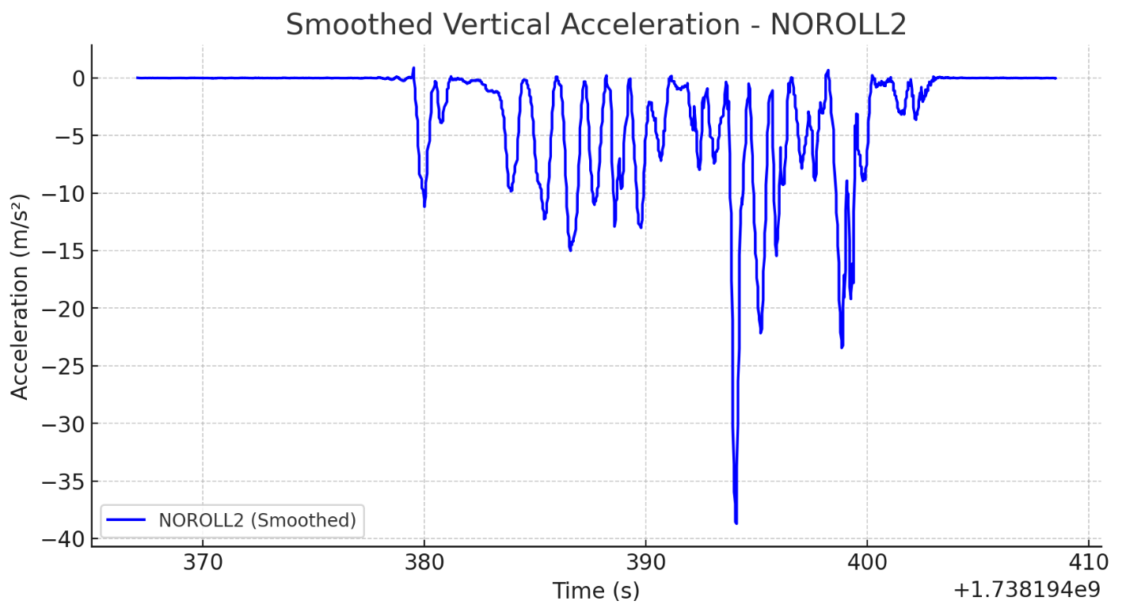

Benchmark Velocity:

63

66

73

69

67

71

72

74

# 3RUBEN NATURAL FORM 1

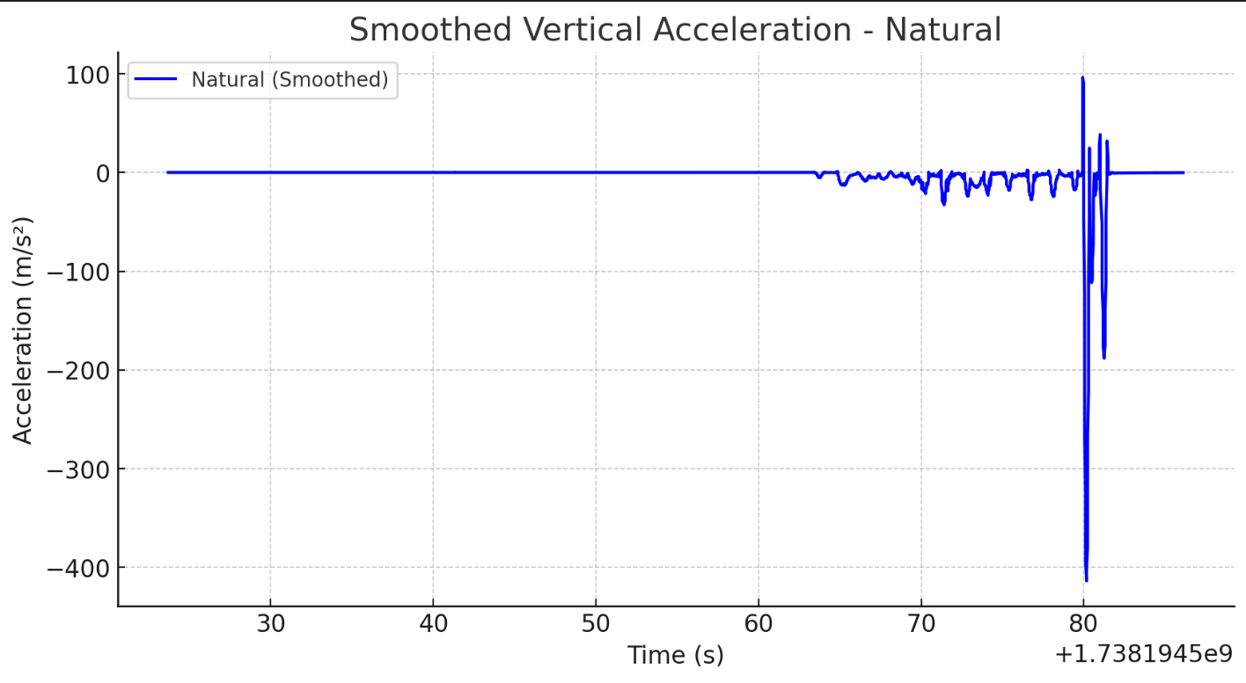

Benchmark Velocity:

91

95

98

97

98

94

94

98

# 4RUBEN NATURAL FORM 2

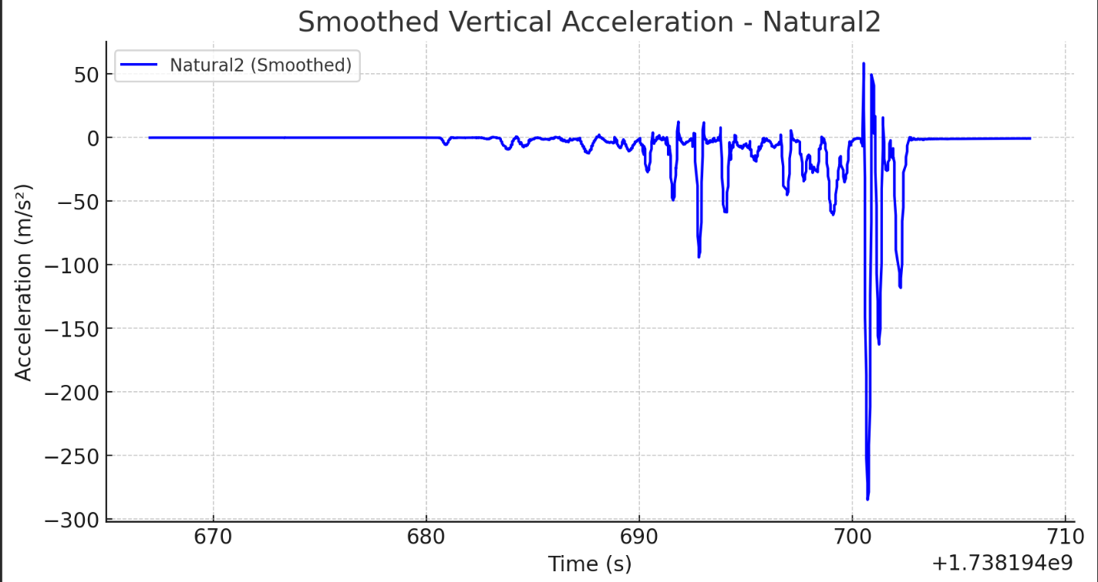

92

94

97

97

1.01

.93

.91

.94

# 5. NATURAL JACOB

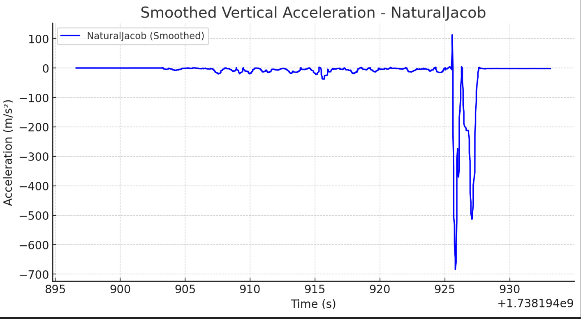

0.77

0.82

0.81

0.85

0.86

0.91

0.83

0.77

# 6. RUBEN FUNKY

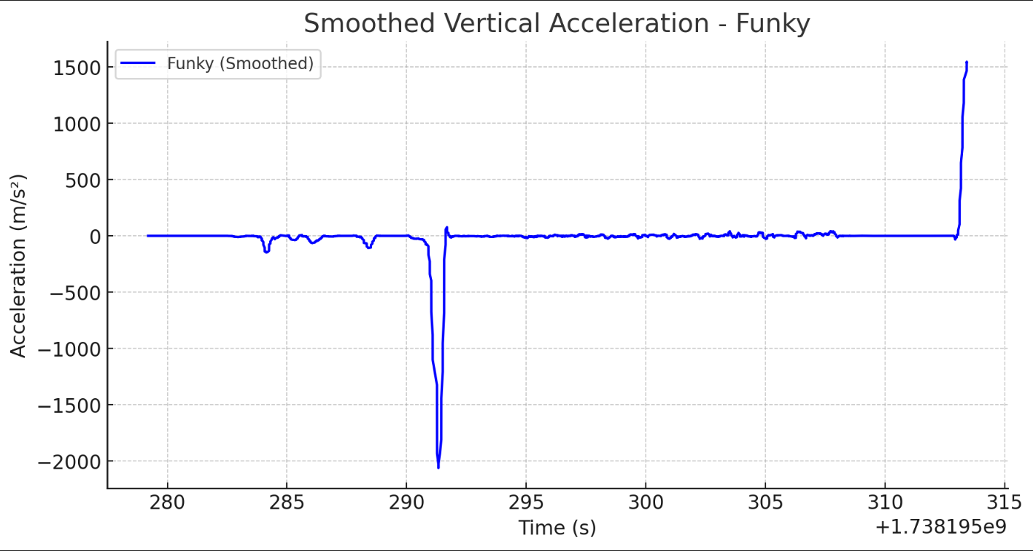

Benchmark Velocity:

.83

.94

.92

.90

.83

.88

.85

.87

# RUBEN FAILSIM+LONG IN BETWEEN REPS

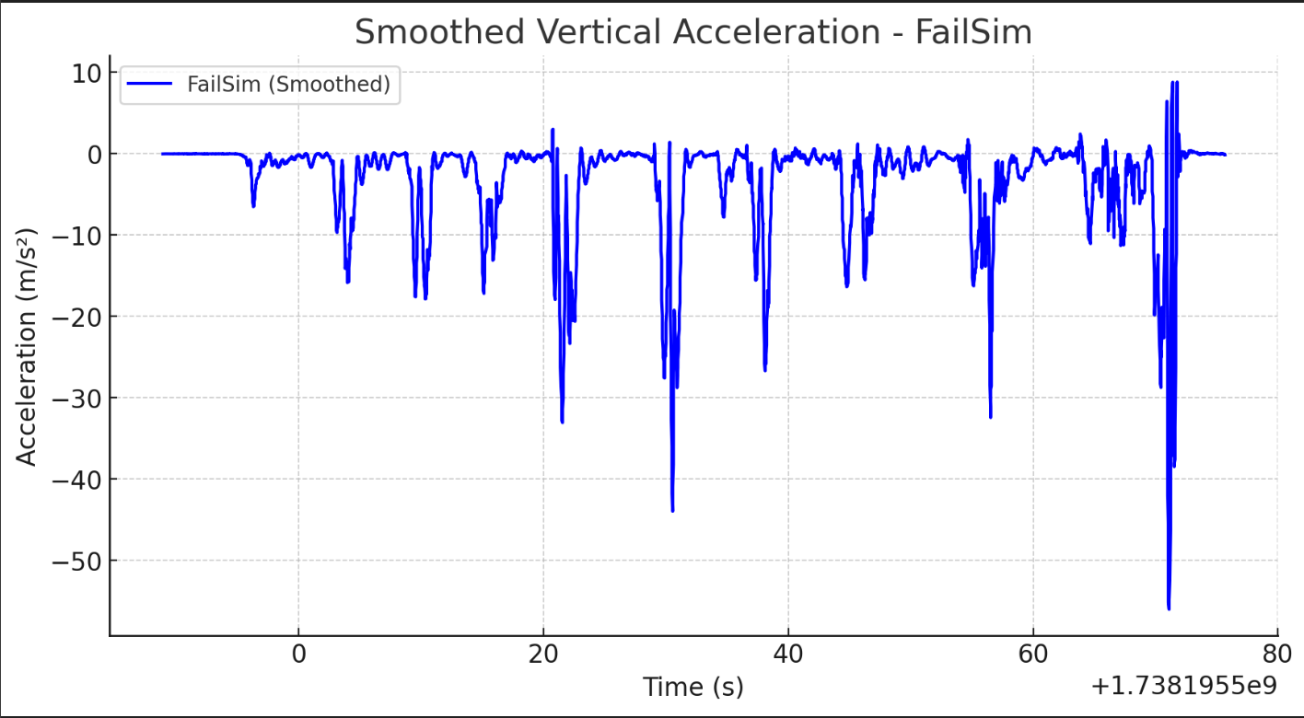

Velo

0.94

.97

.96

.76

.75

.79

.32

.26